Lesson
Reading Between and Behind the Lines
: Using A.I. to understand the hidden messages in photos and pictures.
Lesson Rationale
Learners with additional support needs often decode text effectively but struggle with comprehension, particularly when it involves abstract ideas and implicit meanings.
This lesson uses AI as a "thinking partner" to help learners analyse key themes, clarify complex messages, and uncover bias in news imagery.
By externalising their thought processes with AI, learners develop critical and abstract thinking skills, allowing them to navigate media with greater confidence.
References
Chung, S.K., 2013. Critical visual literacy. The International Journal of Arts Education, 11(2), pp.1-36
Janks, H., Dixon, K., Ferreira, A., Granville, S. and Newfield, D., 2013. Doing critical literacy: Texts and activities for students and teachers. Routledge.
Nelson, S., 2018. Critical literacy and engagement in special education.
Temple, C., 2005. Critical thinking and critical literacy. Thinking Classroom, 6(2), pp.15-20.

Learning Intention / What We Are Learning
We are learning how to use AI to analyse and evaluate hidden messages in images.
Success Criteria / How We Know We Have Learned It
- I can use AI to explore different opinions in news pictures.
- I can identify positive, negative, or neutral messages in news pictures.
Curriculum Links
CfE English and Literacy: LIT 2-18a; ENG 2-19a; LIT 3-18a; ENG 3-19a
Starter
- Activity: Play a Real or Fake News Quiz (e.g. BBC Fake News Quiz)
- Discuss: How did you decide what was real or fake?
- Introduce AI as Critical Thinking Tool:
  - Show a misleading image (e.g. someone appearing to "hold up" the Leaning Tower of Pisa).
  - Ask ChatGPT: “What does this image suggest?”
  - Compare AI's response to learners’ thoughts.
- Key Terms:
  - Bias: A preference for or against something.
  - Critical Literacy: Thinking carefully about words and pictures to understand hidden meanings.
  - AI’s Role: AI can help identify patterns and perspectives but may also reflect existing biases.

Main Learning Activity: Analysing News Images with AI
Introduction: Words and Pictures Can Mislead
- Write on the board: "You are finished."
  - Does this mean "Well done!" or "You’re in trouble!"?
- Show optical illusions (e.g., Vase or Two Faces? Duck or Rabbit?).
- Discuss: Why might different people see different things?
- Link to media: News images are chosen to shape opinions.
Vase or Two Faces? | Duck or Rabbit?
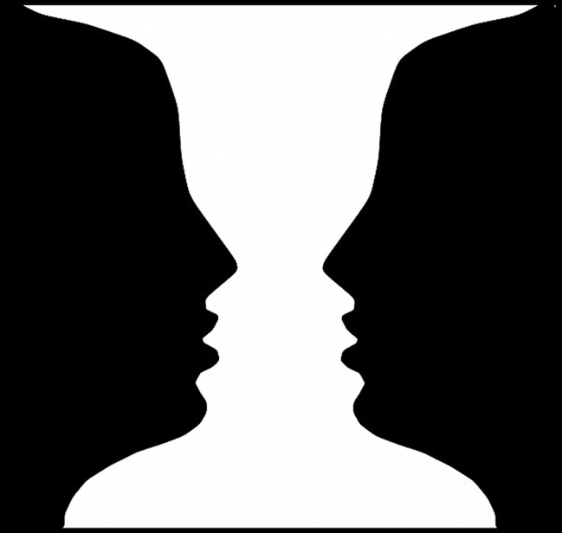 | 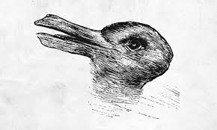

Learning Task: AI vs. First Impressions
Picture 1

Picture 2


Task 1: First Thoughts – What Do You See?
- Look at Picture 1.
- Discuss Observations:
What do you notice?
How do the people in each picture seem to feel?
What do you think each picture is trying to tell us?
- If ready, look at Picture 2 for comparison.
- Key Question:
Do both pictures make you feel the same way, or do they suggest different ideas?
- Reflection Prompt: Why do you think you saw the picture that way?
Task 2: Use AI to Uncover the Message
- Upload Picture 1 to ChatGPT.
- Ask AI: "What message does this picture tell us?"
- Compare AI’s answers to your first thoughts.
- Use a Bias Scale to decide if AI sees the image as positive, neutral, or negative.
Task 3: Spotting Bias with AI
- Step 1: Look at AI’s responses for both pictures.
- Step 2: Use Bias Scale to assess each response.
- Step 3: Compare how AI interprets the images. Does it describe them differently?
- Step 4: Discussion Prompts:
  - I think this image is biased because...
  - AI’s response was fair/unfair because...
  - If you only saw one of these pictures, what would you believe about the event?

Task 4: Explore Different Perspectives
Step 1: Match AI-Generated Statements to Roles
- Before generating responses, learners match pre-written AI responses to these roles:
  - Journalist - Reporting the event.
  - Politician - Speaking about immigration.
  - Refugee - Experiencing the moment firsthand.
  - Police Officer - Assisting with the arrival and keeping order.
- Discuss: How do different roles describe the same event differently?
Step 2: Generate AI Responses
- Use ChatGPT to create a short statement for two different roles.
- Copy and paste one of these prompts into AI:
  - Journalist: “Write a news story about refugees arriving by boat.”
  - Politician: “Write a speech about the challenges of immigration.”
  - Refugee: “Write a personal story from someone fleeing danger.”
  - Police Officer: “Write a short explanation from a police officer during a migrant rescue.”
Step 3: Check for Bias
- Use the Bias Scale:
  - Positive - Shows refugees as welcome, brave or in need of support.
  - Neutral - Gives only facts, no strong or personal opinion.
  - Negative - Shows refugees as dangerous or a problem.
- Compare: Do different roles describe the same event in different ways?
Step 4: Discussion & Presentation
- Groups present their AI-generated responses to the class.
- Class discussion:
  - Which version do you trust the most? Why?
  - How might bias influence public opinion?
  - If you only read one version, would you see the full picture? Why or why not?

Picture 3


Independent Extension Task:
Investigating Media Bias Through AI-Generated Headlines
- Choose an Image:
Use a pre-selected image or find a news image online.
- Use AI to Explore Bias in Headlines:
  - Upload the image to ChatGPT.
  - Ask AI to generate:
    - A positive or supportive headline.
    - A negative or critical headline.
- Compare AI Headlines to Real News Reports:
  - Find two real headlines about the same event.
- Identify Bias Using the Bias Scale.
- Present Findings to the Class:
  - Compare AI-generated and real headlines.
  - Discuss how bias shapes perception.

Plenary: AI & Media Literacy in Everyday Life
Scenario:
- You see a shocking news story on social media with an eye-catching picture.
Ask yourself:
- Is it true? How can you check?
- How might the picture or words influence your emotions?
- How could AI help you think more critically about the message?
Self-Assessment: Exit Ticket
- Rate AI’s impact on your thinking (Helpful / Confusing / Biased).

