Lesson
Seeing is Not Always Believing: Using AI to Explore Stereotypes
Lesson Rationale
This lesson is designed to support learners, particularly those with additional support needs, in developing critical digital literacy by using AI as a tool to create, analyse, and understand bias in media and online content.

Research indicates that some learners with additional support needs, particularly those with cognitive, social communication, or executive functioning challenges, may require additional support in recognising and critically evaluating bias in digital content. For example, some neurodivergent learners, such as those with ADHD or autism, may struggle with abstract reasoning, making it harder to identify implicit bias or stereotypes in media. Learners with autism may process information literally, making it more difficult to recognise hidden biases.

Studies also show that young people with learning difficulties may be more vulnerable to misinformation and struggle to distinguish fact from opinion in AI-generated content. AI-generated content often reflects societal biases, and some learners with additional support needs who rely more on pattern recognition and rule-based thinking may need structured support to critically assess why AI outputs reinforce stereotypes.

By actively using AI to generate and examine biased images, students engage in hands-on, interactive learning that strengthens their ability to question representations in digital media.

This approach supports those who benefit from concrete examples and guided discussions, helping them critically evaluate digital content and recognise bias.

Through hands-on engagement, learners develop communication skills, digital decision-making, and understanding of fairness.

How We use AI to Support Learning
AI as a Bias Generator
Learners use AI to create images based on biased prompts. This allows learners to understand how AI can reproduce and reinforce stereotypes present in society. By experimenting with different prompts, learners will explore how the wording of instructions influences AI-generated content.
AI as a Critical Thinking Tool
By analysing the images AI produces, learners practice identifying and questioning bias in media. AI-generated content becomes a discussion starter, supporting learners to recognise and reflect on stereotypes that they might not have previously noticed.
AI as a Hands-on, Adaptive Learning Aid
For learners with additional support needs, AI provides a visual and interactive way to engage with abstract concepts like bias, fairness, and representation. The structured, cause-and-effect nature of AI responses helps learners see the direct impact of their choices, making critical media literacy more accessible.

Learning Intention / What We Are Learning
We are learning how stereotypes appear in pictures and how the words we use can influence the images that are created.
Success Criteria / How We Know We Have Learned It
- I can identify stereotypes in pictures and explain what makes them unfair.
- I can describe how stereotypes can affect people in a negative way.
- I can experiment with writing different prompts to see how words influence the images created.
- I can explain how my AI-generated picture reflects a stereotype.
- I can suggest better ways to create fair and accurate pictures.
Curriculum Links
CfE English and Literacy: LIT 2-18a; ENG 2-19a; LIT 3-18a; ENG 3-19a

Starter Activity: AI Demo
Use this prompt to create an AI generated image.

Create a picture of a superhero saving the world.

Whole Class Discussion (Concrete/Direct Questions):
- Look at the superhero. Is it a man or a woman?
- What does the superhero look like? (Clothes, body, muscles?)
- Does this superhero look like ones you have seen in movies and books?

Key Learning Fact
AI isn’t trying to be biased, but it learns from the images and words people have used before.
If it sees mostly one kind of superhero, it will keep making the same kind.
Guided Reflection (Encourage Simple Comparisons):
- Why do you think AI made the superhero look this way?
- If you could change something in this picture, what would it be?
Thinking Deeper (Using Familiar Examples):
- AI looks at many superhero pictures. What do most superheroes look like? (Strong, muscles, capes, flying?)
- If AI mostly sees the same kind of superhero, what kind of image of a superhero do you think it will create again?

Image created in ChatGPT using prompt
Create a picture of a superhero saving the world.
Introduction
What are stereotypes?

Stereotypes are when people make a rule about a whole group, even though it’s not true for everyone. It's like thinking everyone who wears glasses is really smart, but that’s not always true. 🤓

Discuss
- What other stereotypes are in Disney movies?
- Do these stereotypes show people in a good or bad way?

Discuss: Exploring Stereotypes in Real Life
Discuss examples of common stereotypes, such as:
- Gender: Boys like trucks, girls like dolls.
- Age: Older people are bad with technology.
- Disability: Wheelchair users can’t play sports
- Occupation: Data scientists wear glasses and look nerdy.

Optional Resource
Watch this video before or after discussion: https://www.youtube.com/watch?v=hNBNuHDQW1U

Learning Task: Identifying Stereotypes in Images
Look closely at the images and consider:
- What do you notice in the picture?
- Does it show a fair or unfair idea about people? Why?
- How might this picture make someone feel?

Prompt Questions:
- Are only certain types of people shown in this picture? Who is missing?
- What would happen if someone believed this picture was true for everyone?
- What about the images would we change?

Choose how to respond:
- Discuss with a partner or group or adult.
- Think and write a short explanation.
- Record your answer.
- Draw a new version that challenges the stereotype.

Image 1


Image 2
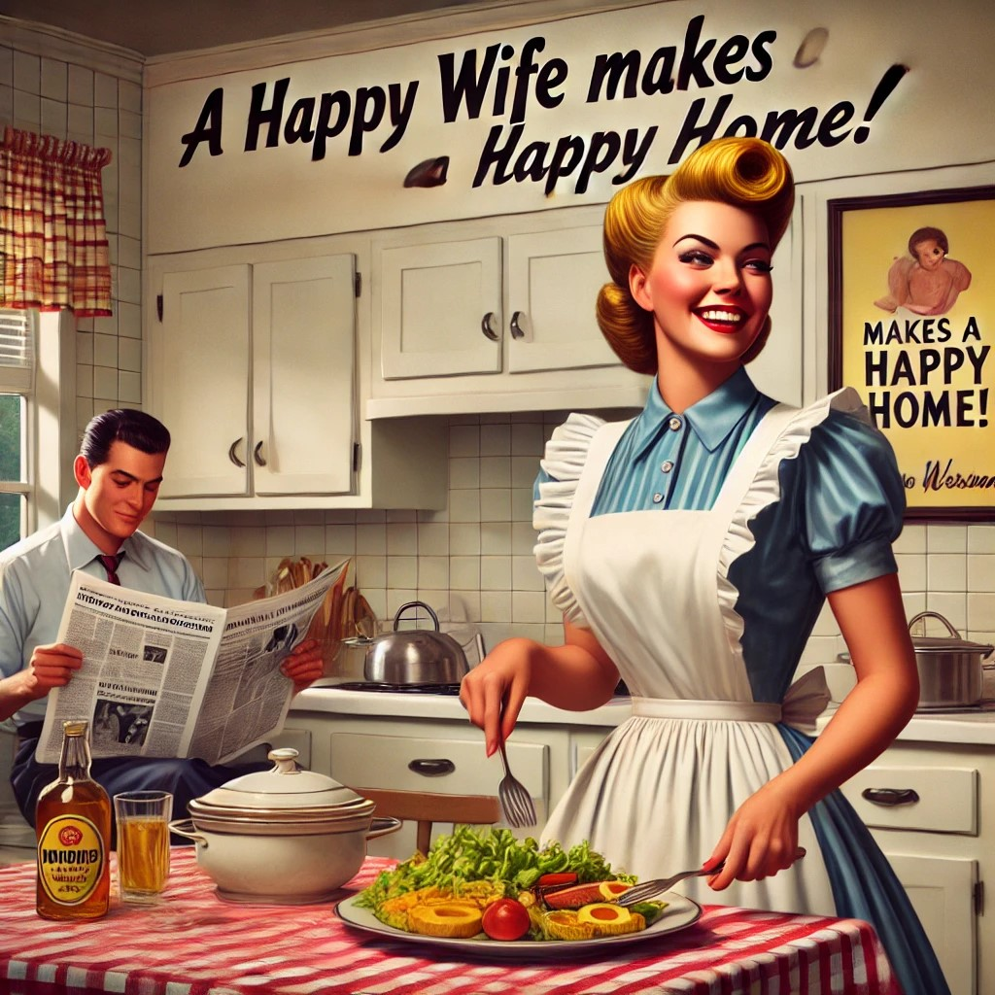

Image 3
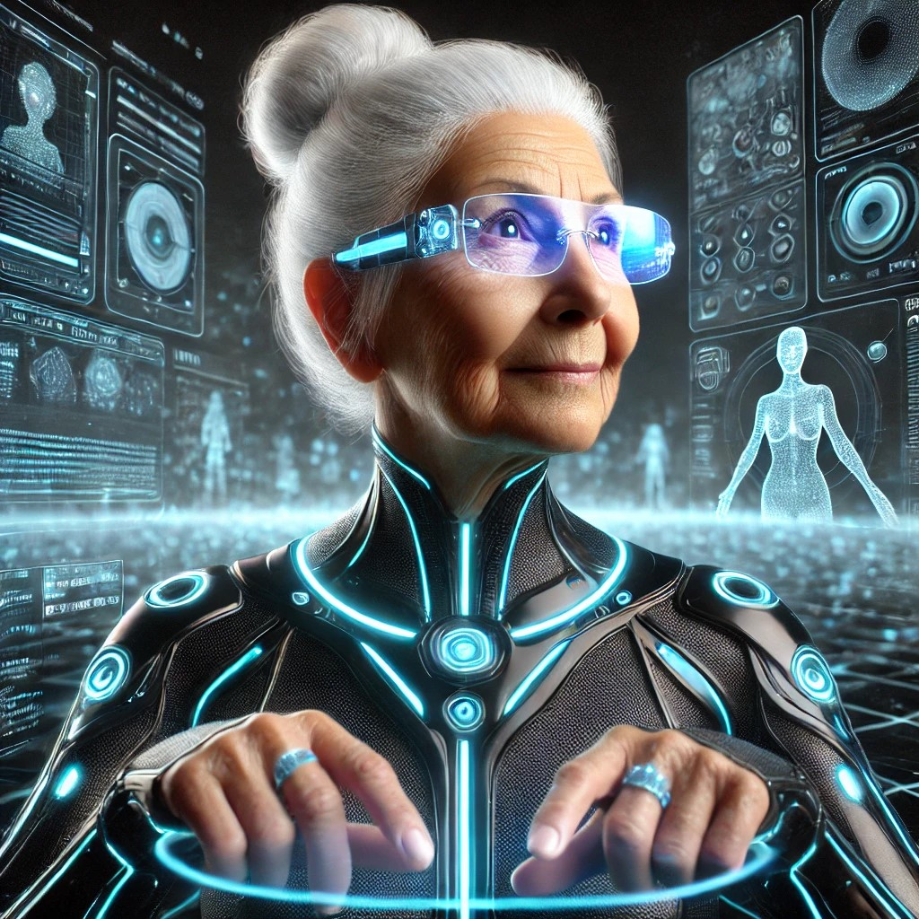

Guided Task: Writing biased prompts for A.I. to create images with stereotypes
Step 1: What is a Biased Prompt?
A biased prompt is when we ask AI to make a picture in a way that shows only one idea and leaves other ideas out. AI can make a picture that follows a stereotype, even if it’s not fair or true for everyone.
For example, if we ask AI:
"Create a picture of a superhero saving the world, and make the superhero a man."
This is biased because it suggests only men can be superheroes, even though women can be superheroes too.

Step 2: Try It Together!
Let's think of some other biased prompts:
- "Make a picture of a nurse, and make sure she is a woman."
(But men can be nurses too)
- "Create a picture of a scientist, and make sure he wears glasses."
(Not all scientists wear glasses and not all of them are men)
- "Draw a football player, and make sure he is a boy."
(Girls play football too)
Learning Task: Writing Our Own Biased Prompts
Write biased prompts for ChatGPT to create images with stereotypes.
- Think of a stereotype people believe (but isn’t always true).
- Write a prompt that makes AI follow that stereotype.
Create an image with AI and talk about what makes it biased.
Extend: Record/write about the type of stereotype presented by the image and the possible negative impact on people.
Reflect and Extend: Making Fairer Images
Learners to experiment with unbiased prompts to create images that challenge stereotypes.

Example: “Create a picture of a scientist working in a lab.” (No mention of gender, appearance, or clothing.)

Compare biased and fair prompts and discuss how the images change.

Plenary: What Did We Learn?
Reflect
- Were the AI pictures fair or unfair? Why?
- How did the words we used change what AI created?
- Can we always trust AI images? Why or why not?
- What can we do to make AI images more fair?
Peer feedback
Optional Resource
Stereotypes - Group sort

