Lesson
Seeing and Hearing: Using AI to Enhance Experiential and Sensory Learning
Lesson Rationale
For learners with severe and complex needs, traditional learning environments often rely heavily on visual and written information, which can create barriers to access. While some classroom settings are adapted for diverse needs, many indoor and outdoor spaces - including community centres, parks, and cultural venues are not designed with sensory learning in mind.

This lesson introduces AI-generated sound as a tool to make physical spaces more accessible and engaging. By transforming images into sound, learners are invited to explore and connect with their environment in a sensory-rich, inclusive way. This supports spatial awareness, sensory processing, and learner agency, allowing individuals who process the world through movement, sound, or tactile interaction to fully participate in experiential learning.

Although AI as a concept may be beyond the cognitive capacities of some learners, this does not mean they should be excluded from experiences that use AI to enhance learning. Rather than focusing on teaching AI itself, this lesson integrates AI as a tool to create opportunities for learners to explore, express their interests, and interact with their environment in ways that suit their individual needs.

Exploring Environments Through Sound
Physical spaces—indoors and outdoors—can become rich, multisensory learning environments when approached with curiosity and flexibility. Whether it’s a quiet classroom, a bustling park, or a dimly lit corridor, these environments can invite exploration, interaction, and play.

This lesson helps learners engage with any space through sound. By taking photos of things that interest them and using AI to convert those images into sound, learners are supported to make sense of their surroundings in an intuitive, sensory way.

How the Process Works:
- Learners take photos of objects, spaces, or of anything that interests them.
- Teachers and Pupil Support Assistants use AI to transform images into abstract soundscapes.
- Learners listen and respond to these soundscapes, using them to build connections between sound, space, and experience.

The sounds created will be experimental and may not directly match the visual elements of the photos. Instead, they offer a different way to experience museum content, encouraging spatial recognition, interaction, and engagement through auditory input. This approach is particularly beneficial for learners who process the world through sensory experiences rather than traditional visual or language-based learning.

Throughout the activity, encourage learners to make choices by selecting images, deciding which sounds they prefer, and expressing their responses through movement, vocalisations, or gestures. Where possible, allow learners to lead parts of the process, reinforcing their agency and independence in exploring sound.

How This Supports Learning
This lesson aligns with the Milestones framework (Education Scotland) for learners with complex additional support needs. It supports key areas of development:
- Sensory Engagement: AI-generated sound provides an alternative way to explore the environment, helping learners discover sensory preferences, regulate emotions, and stay engaged in new spaces.
- Recognising Patterns & Thinking Skills: Even though the sounds do not replicate sound in a recognisable way, learners begin to notice patterns in AI-generated audio. Recognising repeated sounds or rhythms supports listening skills, cognitive flexibility, and cause-and-effect understanding.
- Understanding Space & Environment: Soundscapes offer an alternative way to navigate space. By linking a sound to an image they chose, learners start to connect sound with place, helping with spatial awareness and environmental mapping.
- Communication & Expression: Abstract sounds encourage open-ended responses, allowing learners to express themselves through movement, vocalisation and gestures. This provides opportunities for learners who are non/minimally verbal to share their thoughts and interact with others.

Rather than replicating reality, AI-generated soundscapes expand the ways learners can engage with their surroundings. AI encourages curiosity, exploration, and interaction.
AI as a Tool for Inclusive Learning
This lesson is not a fixed method but a starting point for exploring how AI can support sensory and experiential learning. Every learner has unique needs and interests, and AI can be used in flexible ways to support their learning and development.

Beyond sound, AI can also support learning in other ways, such as:
- Creating AI-generated images for those who engage more with visuals than text.
- Simplifying text to make information more accessible.
- Supporting communication for learners who are non/minimally verbal.

By observing how learners respond to AI-generated sound, teachers and pupil support staff can gain valuable insights into their sensory preferences, learning styles, and ways of perceiving the world.

Linking Learning to SQA National 1 Qualifications
This lesson aligns with the SQA National 1 Science in the Environment: Sensory Perception unit (J5HB 71), which focuses on single and multisensory experiences.
Learners engage with AI-generated soundscapes (hearing) and photography (vision), supporting their sensory exploration of museum spaces.
The lesson encourages multisensory engagement by linking sound to visual elements and spatial recognition.

Learning Objective
- Learners will experience single and multisensory engagement by taking photos of objects, textures, or environments that interest them.
- Learners will explore AI-generated soundscapes created from their photos, identifying differences in sound based on image characteristics (e.g., colour, contrast, patterns).
- Learners will engage in multisensory interactions by linking sound to their environment, using touch, movement, or observation to explore objects or surroundings related to their AI-generated sounds.
- Teachers and support staff will observe and document learners’ responses to identify sensory preferences, patterns of engagement, and emerging cause-and-effect understanding.
- Learners will revisit museum spaces to compare real-world sensory experiences with AI-generated sounds, supporting spatial memory, recognition, and deeper sensory engagement.
Key Vocabulary & Symbols
- Photo (symbol/photo card of a camera)
- Sound (symbol/ear icon)
- Look (eye symbol)
- Listen (ear symbol)
- Choose (hand pointing)
- Feel (hand touching)

Exploring the Environment: Supporting Learner Agency and Experience
When visiting or exploring a space, support learners in making choices and becoming more aware of how different environments affect their senses. This could be in a classroom, outdoor area, quiet hallway, or local community setting.

1. Preparing for the Experience
- Plan a route or space with a variety of sensory features—e.g. bright/dim lighting, quiet/noisy areas, hard/soft surfaces.
- Identify key places or objects that might interest learners (e.g. a tree, bench, bin, textured wall, soft furnishings, classroom objects).
- Use visual supports, symbols, or sensory cues (like tactile objects or reference cards) to help learners anticipate what’s ahead.

2. Encouraging Exploration and Choice
- Let learners lead when possible. Follow their interest, direction of gaze, or physical movements.
- Offer time to pause and observe responses - watch for signs of curiosity, discomfort, or preference.
- Support learners to express choices using their preferred communication method (gesture, pointing, vocalisation, symbol, AAC, etc.).

3. Thinking About Different Sensory Experiences
- Quiet vs. Loud Spaces: Be aware of sudden noises or background sounds like footsteps, wind, or traffic.
  - Support learners by offering noise-cancelling headphones or breaks if needed. Create quiet zones as needed.
- Bright vs. Dark Spaces: Natural light, flickering bulbs, or shadows may affect learners differently.
  - Adjust routes or support accordingly.
- Touchable vs. Non-Touchable Objects: Some items may be safe to touch, others are only for looking.
  - Where touching isn’t allowed, describe textures aloud or offer alternative sensory items.
Learning Task 1: Taking Photos of Things of Interest (In the Environment)
- Support learners to explore a chosen space and take photos of things that interest or engage them.
- Encourage learners to take a photo using:
  - A tablet with a touch screen.
  - Hand-over-hand support if needed.
- Watch for:
  - Signs of choice or interest (reaching, looking, repeating)
  - Whether learners look through the tablet before taking a picture
  - Repetition of actions or objects
Observation Focus
- What objects or environments do individuals choose or express a preference for?
- Do learners look at the object through the camera/tablet before pressing?
- Do learners seek repetition?
Example Observations
- “He took 3 pictures of the yellow chair - he kept going back.”
- “She reached up and pointed at the classroom light before pressing the button.”
Examples
Image 01 | Image 02
 | 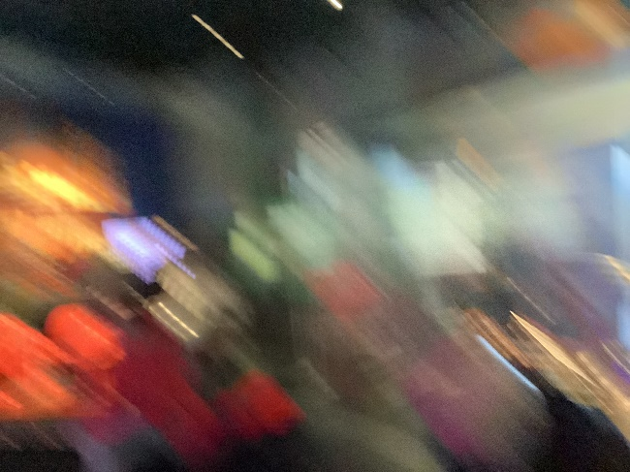
In the museum he liked the big brown boat | She took a photo while we were moving
Image 03 | Image 04
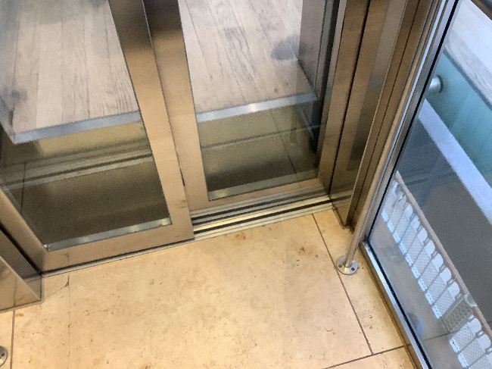 | 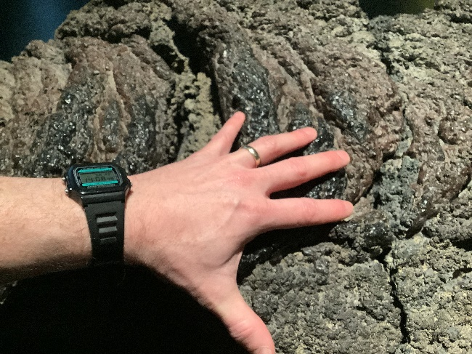
She liked pressing the buttons in the lift | He felt the rough texture and smiled

Learning Task 2: Transforming Images into Sound (Back in Class)
Image to Music is free, simple to use, and doesn’t require a login. It has an easy interface, making it accessible for educators and learners.
https://imagetomusic.top/
How to Use Image to Music
- Go to the Website
Visit: https://imagetomusic.top
- Upload an Image
Click the “Upload” button.
Choose a photo from your device.
- Select
- Generate Music
After the image loads, click “Make music from my pic”.
Wait a moment for the sound to be created.
- Listen and Explore
Click “Play” to hear the sound.
You can also download it if you want to keep it.
Note: The music is an abstract interpretation of the image—it may sound surprising or different from what you expect. This is part of the creative fun!
Information:
On the Image to Music site, the "Choose Model" option lets you select the type of AI algorithm that will be used to generate sound from your image.
Each model can produce a slightly different style or structure of sound, even from the same picture. For example:
- One model might create calm, flowing sounds.
- Another might generate faster, more rhythmic music.
- Some may use different instruments or tones.
If you're not sure which one to pick, just use the default model, or try a few to see which sound your learners respond to best.

Investigate / Experiment
Step | Activity | Guided Questions / Focus
- Upload an Image | Select and upload an image to the AI tool. | What image did the learner choose?  Are they drawn to a particular colour, shape, or texture?
- Generate the Sound | Click Create and listen to the AI-generated sound. | How does the learner react to the sound?  Do they show curiosity or recognition?
- Compare Different Images | Upload a second image with different features (e.g., dark vs. bright, simple vs. complex).  Play both sounds. | Does the learner notice the difference?  Do they prefer one over the other?
- Explore Variability | Re-upload the same image and listen again. The AI may create a different sound. * | Does the learner recognise repeated sounds or patterns?  Do they notice changes?
- Encourage Expression | Support learners to respond using movement, vocalisation, or choosing preferred sounds. | How does the learner express their preference?  Do they engage/interact more with certain sounds or sound patterns?

* Note:
AI-generated sounds produced are abstract interpretations of images and do not accurately represent real-world sounds. Instead, AI uses patterns to turn pictures into music-like sounds. This means the sounds may not match what you expect and might not seem connected to the image.
This tool is for creative and sensory exploration, helping learners experience images in a new way.

Learning Task 3: Responding to Sound and Image
- Replay the AI-generated sounds alongside images.
- Compare different sounds and images.
- Support learners to interact through movement, vocalisation, gesture, or other behavioural responses.
- Encourage learners to take an active role in responding to the sounds. Let them choose which sound they want to hear again, express preferences, and explore movement or vocalisation in their own way. By allowing learners to lead parts of their learning, you support agency and engagement.
Observation Focus
- Do they prefer high or low sounds?
- Do they look at the screen when certain sounds play?
- Do they vocalise, laugh, sway, or look away?
- Do they attempt to repeat or request a sound again?

Learning Task 4: Revisiting the Environment
- Return to the same physical space.
- Support learners to reconnect with what they photographed before.
- Take new photos, or re-listen to sounds while in the space.
Observation Focus
- Did learners show memory or recognition of the space or object?
- Were they more confident or expressive in their responses?
- Did they notice or choose something new?

