**Midge Season**

**Introduction**

Train a machine learning model to recognise voice commands ‘up’, ‘down’, ‘left’, and ‘right’, and use them to control a biting midge in a fun game.

You will need:

* a microphone
* Scratch file: **Midge Season.sb3**
* This project uses a technology called ‘machine learning’. Machine learning systems are trained using a large amount of data.
* This project does not require you to create an account or log in. For this project, the examples you use to make the model are only stored temporarily in your browser (only on your machine).

**Set Up the Project**

Go to [machinelearningforkids.co.uk](https://machinelearningforkids.co.uk/#!/login) in a web browser.

Click on **Get started**.

Click on **Try it now**.

Click on **Projects** in the menu bar at the top.

Click on the **+ Add a new project** button.

Name your project Midge Season and set it to learn to recognise **sounds**, and store data in your web browser. Then click on **Create**.

You should now see ‘Midge Season’ in the projects list. Click on the project.

Click on the Train button.

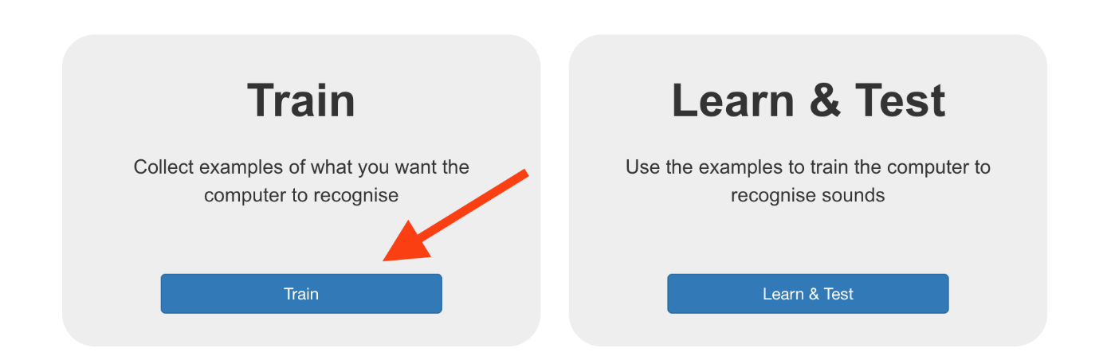

If you see a pop-up message asking to use the microphone, click on Allow.

**Background Noise**

First, you will collect samples of background noise. This will help your machine learning model to tell the difference between your voice commands, and the background noise where you are.

Click the + **Add** example button in background noise.

Click on the microphone but don’t say anything to record 2 seconds of background noise.

Click the **Add** button to save your recording.

Repeat those steps until you have at least 8 examples of background noise.

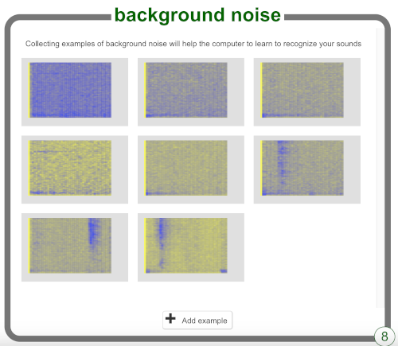

**Record the Directions**

Now you will record 8 examples of each word (‘up’, ‘down’, ‘left’, and ‘right’) so that your machine learning model can learn to recognise them.

Click on + Add new label on the top right of the screen and add a label called left.

Click on + Add example inside the box for the new left label, and record yourself saying “left”.

Repeat until you have recorded at least 8 examples.

+ Add new label to create another label called right and record 8 examples of you saying “right”.

+ Add new label to create another label called up and record 8 examples of you saying “up”.

+ Add new label to create another label called down and record 8 examples of you saying “down”.

You have gathered the examples you need, now you will use these examples to train your machine learning model.

Click on < Back to project in the top left-hand corner.

Click on Learn & Test.

Click on the button labelled Train new machine learning model. This may take a few minutes to complete.

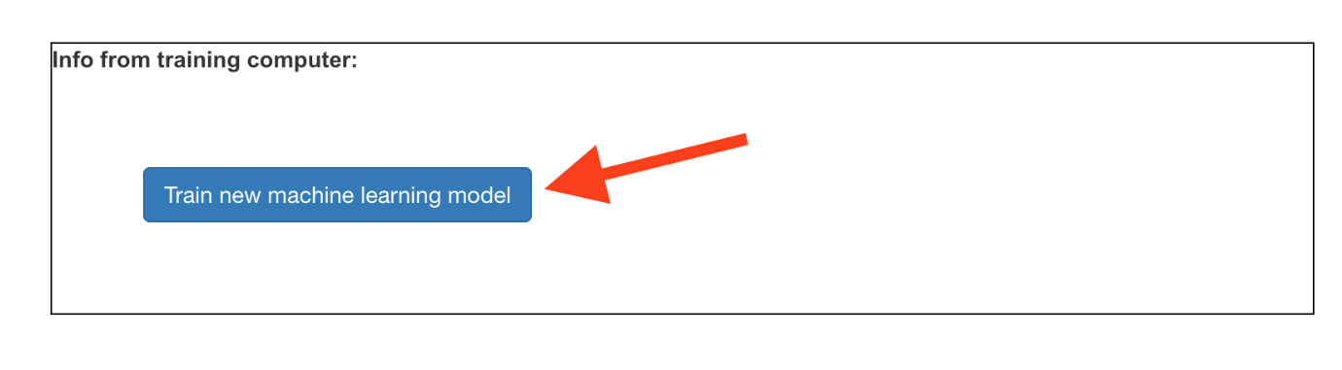

Once the training has finished, you can test how well your model recognises your voice commands.

Click the Start listening button, then say “left”.

If your machine learning model recognises it, it will display what it predicts you said.

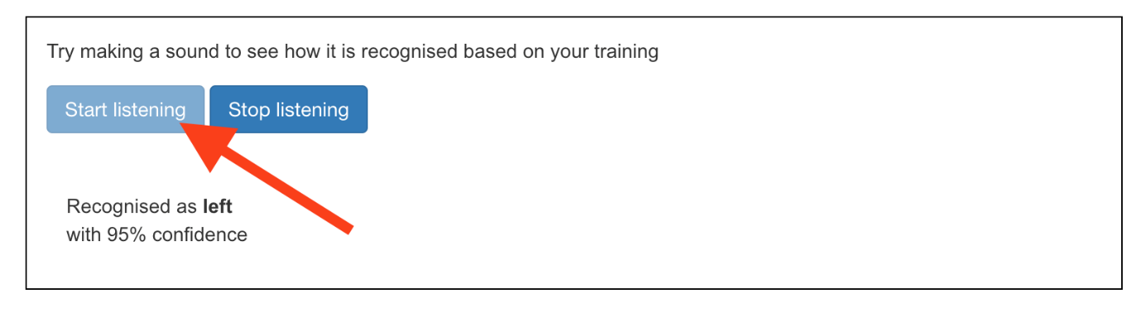

Test whether the model recognises “up”, “down”, and “right” too.

If you are not happy with how the model works, go back to the Train page and add more examples, then train your model again.

**Moving the Midge**

Now that your model can distinguish between words, you can use it in a Scratch program to move a midge around the screen.

Click on the < Back to project link.

Click on Make.

Click on Scratch 3.

Click on Open in Scratch 3.

Click on **File > Load from your computer** at the top and select the ‘Midge Season.sb3’ project. The project comes with sprites, backdrops and code already attached.

Play the game using the arrow keys first to learn how it works.

Take time to read and understand the code on each sprite and the backdrop.

Machine Learning for Kids has added some special blocks to Scratch to allow you to use the model you just trained. Find them at the bottom of the blocks list.

With the Midge sprite selected, click on the Code tab. Find the right place in the code and add a special block to tell the model to start listening.

Add the code for ‘up’ to the Midge sprite.

Look at the code you have to move the Midge up, then see if you can work out the code for down, left, and right.

**Hint**

Click the green flag and say up, down, left, or right. Check that the Midge moves in the direction you expected.

**Challenges**

Midge also like to eat fruit, plants and flowers. Perhaps these might appear at random for extra points?

Could you make a 2-player game with 2 midges?

How could you record another set of voice commands that don’t interfere with Player 1 Midge? (Midge are widespread in the Highlands and Islands of Scotland. Perhaps you could learn the Scottish Gaelic words for Up, Down, Left and Right!)

|  |
| --- |
| **GenAI Images**  Did you know that 2 of the images in Midge Season were created using GenAI tools. Try using GenAI tools to create your own game images (e.g. title sceen) using text prompts. How do they compare to user created images? Can you/players tell the difference? What impact do you foresee for the Games Industry of GenAI tools? Will we still need Graphic Artists? Story Writers? Coders? Sound Engineers? |

**Next Steps**

Investigate other Scratch games that might be fun to control with voice commands!

Idea based on Fish Food project by the [Raspberry Pi Foundation](http://www.raspberrypi.org/) licensed under a [Creative Commons Attribution 4.0 International licence](http://creativecommons.org/licenses/by-sa/4.0/).